SOP: CREATING USERS IN IORPMS
(Last updated: July 2025)
Background | Creating Users
Objective | To provide a simplified procedure for creating users in IORPMS
Who | ICT, HMIS, Dev team
Required Materials | - Laptop or Desktop  - No internet required

Step | Action | Screenshots
 | Go to settings>register user | 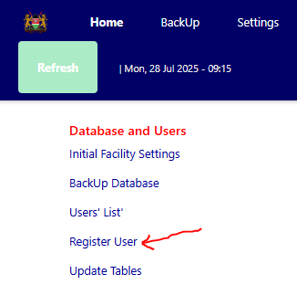
 | Fill in the details of the users. For user role please select the appropriate user role. Examples: Admin, Clinician, Pharmacist etc  The default password is 123456 which should be changed by the user once the log in | 